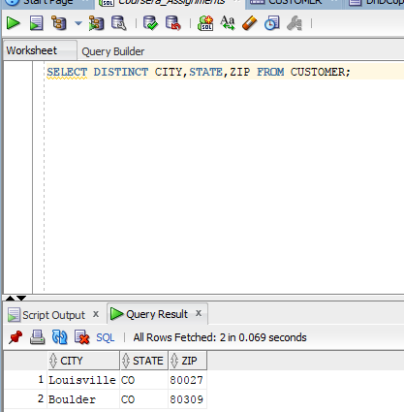
SELECT DISTINCT CITY, STATE, ZIP FROM CUSTOMER;